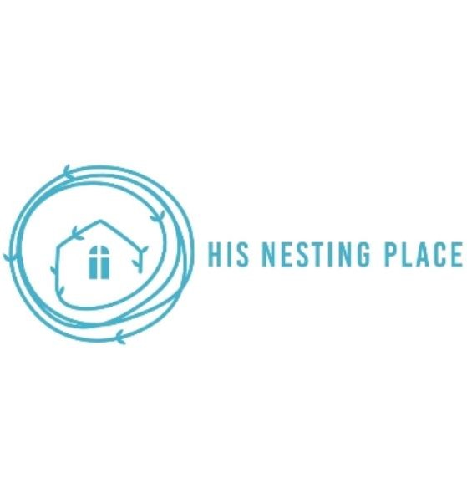

Dear future partners,

Thank you for your interest in serving here at His Nesting Place, we are honored you want to be a part of the work we do here! Our prayer is that whatever you feel you are gifted in, you could utilize it to glorify God through our ministry!

Please be mindful that this is a private home and we must take all precaution to help protect the safety of all of our residents here. In doing so, here are the steps we ask that you take prior to volunteering:

* Fill out application
* Pass a background test
* Reference check
* Interview with staff

Thank you for helping us keep our home safe and in order, we are so excited to partner with you!

With gratitude,

His Nesting Place Family



His Nesting Place Volunteer Confidentiality Agreement

Due to conflicts of interest and privacy policies, we kindly that ask our volunteers do not share any of their personal information nor exchange any information with our residents.

Information such as telephone numbers, emails, social media accounts and addresses are not permitted to exchange between volunteers and residents. This is to establish the safety of both the volunteers and the residents in order to maintain a safe and private home establishment.

*By signing this document, you are agreeing to this policy we have set in place*

Name __________________________________________ Date___________________

Sign __________________________________________

|  |  |
| --- | --- |
|  | Volunteer Application |

# Date __________________

## Information

|  |  |  |  |  |  |
| --- | --- | --- | --- | --- | --- |
| Full Name: |  |  |  | Date: |  |
|  | Last | First | M.I. |  |  |

|  |  |  |
| --- | --- | --- |
| Address: |  |  |
|  | Street Address | Apartment/Unit # |

|  |  |  |  |
| --- | --- | --- | --- |
|  |  |  |  |
|  | City | State | ZIP Code |

|  |  |  |  |
| --- | --- | --- | --- |
| Phone: |  | Email |  |

|  |  |  |  |
| --- | --- | --- | --- |
| Church you attend: _____________________________ |  | Pastor: |  |

If required, could you get a recommendation from your Pastor? ____________________________________________

## Availability

|  |  |  |  |
| --- | --- | --- | --- |
| Days and Dates available | Evenings | Mornings | M  T  W  TH  F  SA  SU |

|  |
| --- |
| When are you ready to start? ________________ |

## References

**Please list three references**

|  |  |  |  |
| --- | --- | --- | --- |
| Full Name: |  | Relationship: |  |
| Company: |  | Phone: |  |
| Address: |  |  |  |
|  |  |  |  |
| Full Name: |  | Relationship: |  |
| Company: |  | Phone: |  |
| Address: |  |  |  |
|  |  |  |  |
| Full Name: |  | Relationship: |  |
| Company: |  | Phone: |  |
| Address: |  |  |  |

## Experience

|  |  |
| --- | --- |
| How did you hear about His Nesting Place? |  |
| What interests you in becoming a volunteer? |  |

|  |  |  |
| --- | --- | --- |
| How do you feel you can be used best here? |  | |
| Do you have any previous experience with volunteering? If so, please let us know where and what your experience was like: | |  |

____________________________________________________________________________________________________

## Skills and experience

## Please select all that apply

|  |
| --- |
| Kitchen aide  Child care  Gift wrapping Social media/Marketing  Maintenance (handy work) Computers (IT)  Automotive Office/ Clerical  Ministry (Bible studies)  Construction Fundraising  Sidewalk counseling  Cleaning/organizing  Other  *Please specify:* |

|  |
| --- |
| Emergency contact Name ______________________ Relationship: _____________________ Number: ___________________________ |

## Disclaimer and Signature

I certify that my answers are true and complete to the best of my knowledge.

If this application leads to employment, I understand that false or misleading information in my application or interview may result in my release.

|  |  |  |  |
| --- | --- | --- | --- |
| Signature: |  | Date: |  |

## Waiver of liability His Nesting Place

*In consideration of the opportunity afforded me to volunteer or reside at His Nesting Place, in light of community service provided by His Nesting Place, I hereby waive any right or cause of action arising as a result of my participation volunteering or residing at His Nesting Place from any liability which may or could occur against His Nesting Place or its officers and directors collectively or individually. Without limiting the generality of the forgoing, I agree that this waiver shall include and rights or caused of action resulting from personal injury to me or damage to my personal property sustained in connections with my activities from volunteering or residing at His Nesting Place.*

Name ______________________________ Date ___________________

Signature ________________________

If applying online, please return these copies via e-mail to

[Howardgeri88@yahoo.com](mailto:Howardgeri88@yahoo.com)

[C21diana@hotmail.com](mailto:C21diana@hotmail.com)

By mail or in person at:

350 e Market St

Long Beach, CA 90805